UNIT V
Functions: Designing, Structured Programs, Function in C, User Defined Functions, Inter- Function Communication, Standard Functions, Passing Array to Functions, Passing Pointers to Functions, Recursion
Text Input / Output: Files, Streams, Standard Library Input / Output Functions, Formatting Input / Output Functions, Character Input / Output Functions
Binary Input / Output: Text versus Binary Streams, Standard Library, Functions for Files, Converting File Type.
Functions
Designing
- Breaking a complex problem into smaller parts is a common practice in developing software.
- These parts of a program are called as modules and the process of subdividing a problem into parts is called modular programming.
- In this approach a program is divided into a main module and its related modules. Each module can be subdivided into sub modules.
- This design can be represented using a structure chart.
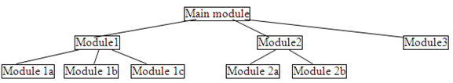
Function in C
- In C the idea of modular programming is implemented using functions.
- A C program is made of one or more functions one of which must be named as main.
- The execution of the program always starts from main. But it can call other functions to do special tasks.
Function – Defintion
- A function is a self – contained block or a sub program which contains a group of statements that performs a required task when called.
- A called function receives control from a calling function. When the called function completes its task, it returns control to the calling function.
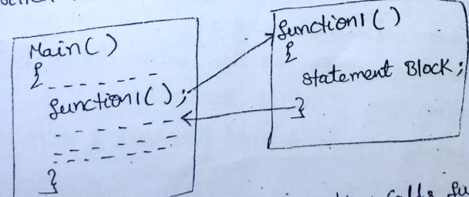
- From the above figure we can see that main() calls function named function1(). Main() is known as calling function and function1() is known as called funciton.
Advantages of functions
- Functions provide a way to reuse the code. Function once written can be used many times.
- Using functions data can be protected since data used in the function cannot be used by outside of the function.
- Using functions, large programs can be reduced to smaller ones and it is easy to find any errors in the program.
Types of functions
- Functions are classified into two types they are:
  - User defined functions
  - Library or built in functions
User defined functions
- User defined functions are defined by the user.
- To use a function in C it must be both declared and defined. A function name is used three times:
For declaration: A function declaration tells the compiler about a function's name, return type, and parameters.
In a function call: Call any function from main.
For definition: A function definition provides the actual body of the function
For declaration
- The function declaration is done before the function call, gives the whole picture of the function. It contains only function header.
Syntax: returntype functionname(type1,type2,…..) ;
Example: void greeting(void);
- Above function declaration specifies that program contains a function with name greeting and it returns nothing and it has no arguments. (void means nothing).
int add(int, int);
- Above function declaration specifies add is the name of function and it returns an int value and accepts 2 int values also known as arguments.
- Variable names are not required in the function declaration.
The function definition
- The function definition contains the code needed to complete the task. It is made up of two parts. They are
  - The function header
  - The function body
- The general form of a function definition is
return_type function_name( parameter list )
{
body of the function
}
- A function header contains three parts: the return type, the name of function, and the formal parameter list.
- A semicolon is not used at the end of function definition header.
- The return_type is the data type of the value the function returns.
- Some functions perform the desired operations without returning a value. In this case, the return_type is the keyword void.
- Function Name is the actual name of the function.
- Parameters are like a placeholder. When a function is invoked, you pass a value to the parameter. They are of two types
  - Formal Parameters
  - Actual Parameters
Formal and actual parameters
- Formal parameters are the variables that are declared in the header of the function definition.
- These are also called as dummy parameters since they don’t have existence until the function is called.
- Actual parameters are used in the calling function.
- Formal and actual parameters must match exactly in type, order, and number of parameters
- The function body contains a collection of statements that defines what the function does. It contains the local declarations and statements.
The function call
- A function can be called once it is defined. Function call has highest precedence in C.
- A function call contains the name of function following the list of arguments enclosed between pair of parenthesize ().
- The parameters in function call are called as actual parameters and the values of these parameters are sent to the called function.
- There are many different ways to call a function.
  - greeting(); // no arguments
  - c = add(a,b) + 10 ; // function call is used in an expression
#include<stdio.h>
double average(int, int); //function declaration
main()
{
int a=10,b=20;
float res;
res = average(a,b); // x,y are actual parameters //function call
printf(“result is %f”,res);
}
double average(int x, int y) // x,y are formal parameters // called funciton
{
float sum;
sum=x+y; //function body
return (sum/2.0);
}

Categories of functions
- All C functions can be called a either with argument or without arguments in a C program. These functions may or may not return values to the calling functions.
- Functions may belongs to one of the following categories:
  - Function with arguments and with return value
  - Function with arguments and without return value
  - Function without arguments and without return value
  - Function without argument and with return value
Function with arguments and with return value
- These function having arguments and that argument are passed to the definition of a function such function will have two-way data communication i.e., here the data is transferred between calling and called function
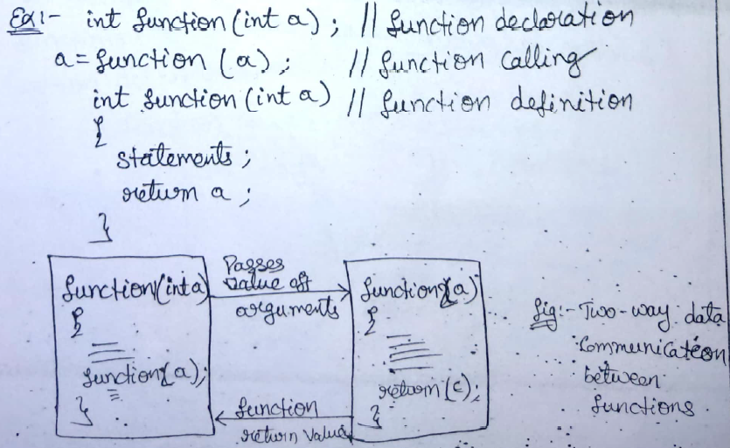
int add(int,int); // function declaration
main()
{
int a,b, ans;
printf(“enter 2 values “);
scanf(“%d%d”,&a,&b);
ans = add(a,b); // function is called in an expression, a,b are actual parameters
}
int add(int x,int y) // function definition, x,y are formal parameters
{
return x+y; // x+y will be returned to called function
}

Function with arguments and without return value
- Arguments are passed to the calling function the called function operates on those values but no result is sent back to the calling function such a functions are partially dependent on the calling function.
void add(int,int); // function declaration
main()
{
int a,b;
printf(“enter 2 values “);
scanf(“%d%d”,&a,&b);
add(a,b); // function call, a,b are actual parameters
}
void add(int x,int y) // function definition, x,y are formal parameters
{
int c; //local variable
c=x+y;
printf(“\n sum = %d “,c);
}
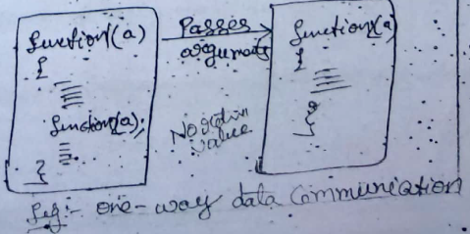
Function without arguments and without return value
- When a function has no arguments it does not receive any data from calling function. Similarly, when it does not return a value the calling function does not receive any data from the called function.
- There is no data transfer between the calling function and they called function
#include<stdio.h>
sum();
main()
{
sum();
}
sum()
{
int a,b;
printf(“enter 2 values “);
scanf(“%d%d”,&a,&b);
c=a+b;
printf(“%d”,c);
}

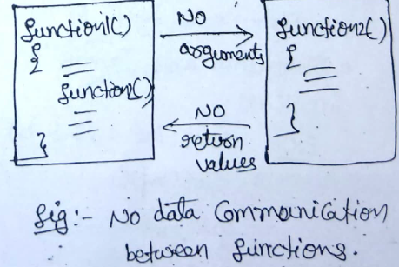
Function without argument and with return value
- The function having no arguments but return a value to the calling function.
int add(); // function declaration
main()
{
int ans;
ans = add(); // function is called in an expression, no parameters
printf(“%d”,ans);
}
int add() // function definition
{ int a,b; // local variables
printf(“enter 2 values “);
scanf(“%d%d”,&a,&b);
return (a+b);
}
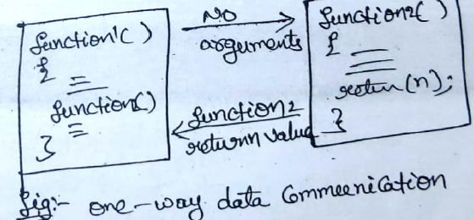
Standard library functions
- Library functions or predefined set of functions, their task is limited.
- A user cannot understand the internal working of these functions. The user can only use the functions but cannot change or modify them.
Example: sqrt(81) - 9
- Pre-defined functions that are provide to perform such as input output functions are printf(), scanf(), puts(), gets().
- Mathematical functions are pow(), sqrt() etc.
Eg libraries are
stdio.h which contains standard input and output functions like printf(), scanf() etc.
stdlib.h which contains standard library functions like rand(), exit() etc.
math.h which contains mathematical functions like pow(), sin(), cos() etc.
string.h which contains string manipulation functions like strlen(), strcat() etc.
Returning a value
- Functions having two different types to returns
  - With return value
  - Without return value
- The function may or maynot send back any value to the calling function, if it is does it is done through the ‘return’ keyword.
Syntax: return(expression); (or) return expression;
- The expression should palced in between paranthesis.
Example: return(a+b); or returnc;
Parameter Passing Techiques
- There are two ways in which arguments or parameters can be passed to the called function. They are:
  - Call by value / pass by value
  - Call by reference / pass by reference
Call by value / pass by value
- In this call by value techique the value of each of the actual arguments in the calling function is copied into corresponding formal arguments of the called function.
- With this technique the changes made to the formal arguments in the called function have no effect on the values of actual argument in the calling function.
void swap (int ,int); // declaration
main()
{
int a,b;
printf(“enter 2 values “);
scanf(“%d%d”,&a,&b);
printf(“\nvalues before swap are “);
printf(“a = %d b= %d “,a,b);
swap(a,b); // function call, values of a,b are passed, call by value
printf(“\nvalues after swap are “);
printf(“a = %d b= %d “,a,b);
}
void swap(int a, int b)
{
int t;
t=a;
a=b;
b=t;
printf(“\nvalues after swap are “);
printf(“a = %d b= %d “,a,b);
}
- In the above program function swap contains 2 arguments. Even though inside the function these arguments are swapped it is not affected in the main program.
Call by reference / pass by reference
- In this type of parameter passing technique address of variables are passed to the function. To hold these addresses the formal parameters must be pointer variables.
- If any change is taking place for an argument in this type that change will be affected in the called function also.
void swap (int ,int); // declaration
main()
{
int a,b;
printf(“enter 2 values “);
scanf(“%d%d”,&a,&b);
printf(“\nvalues before swap are “);
printf(“a = %d b= %d “,a,b);
swap(&a,&b); // function call, values of a,b are passed, call by value
printf(“\nvalues after swap are “);
printf(“a = %d b= %d “,a,b);
}
void swap(int *a, int *b)
{
int t;
t=*a;
*a=*b;
*b=t;
}
- In the above program function swap contains 2 arguments and these are pointer variables.
- Inside the function these arguments are swapped, since pointers are used it is affected in the main program also. That is they will swap in the main.
Recursion
- Recursion is the process in which a function repeatedly calls itself to perform calculations.
Syntax: recursion()
{
recursion();
}
int main()
{
……….
recursion();
…………
return 0;
}
#include <stdio.h>
int fib(int); // function declaration
main()
{
int n,i;
printf(“\nEnter n “);
scanf(“%d”,&n);
for (i=0;i<n;i++)
printf(“%d\t”,fib(i));
}
int fib(int n)
{
if (n==0 || n==1)
return n;
return fib(n-1)+fib(n-2);
}

Inter- Function Communication
- The calling and called function are two separate entities, they need to communicate to exchange data.
- The data flow between calling and called functions can be divided into three strategies:
- Downward flow
- Upward flow
- Bi-directional flow
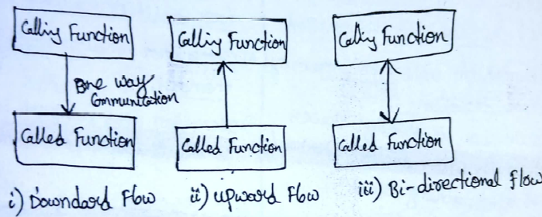
Downward flow
- In downward flow communication, the calling function sends data to the called function.
- No data flow in the opposite direction.
Example: sum();
main()
{
sum();
}
sum()
{
int a=10,b=20,c;
c=a+b;
printf(“%d\n”,c);
}
Upward flow
- Upward flow communication occurs when called function sends data back to the called function without receiving any data from it.
void swap (int ,int); // declaration
main()
{
int a,b;
printf(“enter 2 values “);
scanf(“%d%d”,&a,&b);
printf(“\nvalues before swap are “);
printf(“a = %d b= %d “,a,b);
swap(&a,&b); // function call, values of a,b are passed, call by value
printf(“\nvalues after swap are “);
printf(“a = %d b= %d “,a,b);
}
void swap(int *a, int *b)
{
int t;
t=*a;
*a=*b;
*b=t;
}
Bi-directional flow
- Bi-directional flow occurs when the calling function sends data down to the called function.
#include<stdio.h>
int sum(int a, int b);
main()
{
int a=10,b=20,p;
p=sum();
printf(“%d\n”,p);
}
sum()
{
int c;
c=a+b;
return c;
}
Passing Array to Functions
- Array can pass through calling function, where as we don’t return an array from function.
- Rather we return a pointer holding the base address of the array to be returned. But, we must make sure that the array exits after the function ends.
- Formal parameter as a pointer as follows:
void myfunction(int *p)
{
……
…..
}
- Formal parameter as a sized array as follows:
myfunctio(int p[10]) myfunctio(int p[ ])
{ {
……. ……..
……. …….
} }
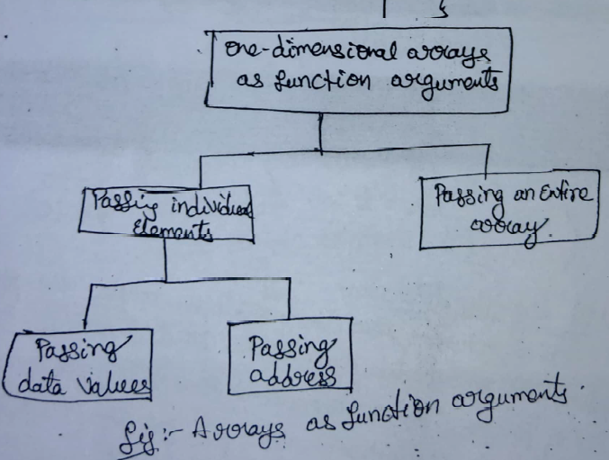
Passing Individual Elements
- Individual elements are passed to functions by simply including them as subscripted vairables in the function call argument list.

Passing data values
#include<stdio.h>
fun(int arr[]);
main()
{
int arr[5]={1,2,3,4,5};
fun(arr[3]);
}
fun(int num)
{
printf(“%d”,num);
}

Passing address
#include<stdio.h>
fun(int *n);
main()
{
int arr[5]={1,2,3,4,5};
fun(&arr[3]);
}
fun(int *n)
{
printf(“%d”,*n);
}
Passing the Entire array
#include<stdio.h>
fun(int arr[5]);
main()
{
int arr[5]={1,2,3,4,5};
fun(arr);
}
fun(int arr[5])
{
int i;
for(i=0;i<5;i++)
printf(“%d”,arr[i]);
}
Passing pointer to function
- Function in a program occupies memory. The name of the function is a pointer constant to its first byte of memory.
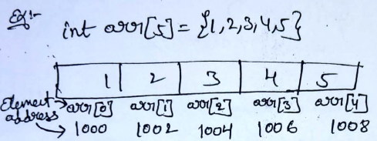
int *p;
p=&arr; or p=&arr[0];
#include<stdio.h>
main()
{
int i;
int a[5]={1,2,3,4,5};
int *p=&a;
for(i=0;i<5;i++)
printf(“%d”,*p);
}

Text Input / Output

Files
- A file is an external collection of related data. The primitive task of using a file is to keep a record of data. If memory is lost when the computer is shut down, we need files to store our data in a more permanent form.
- Files are stored in auxiliary or secondary storage devices. The two most common forms of secondary storage are disk (hard disk, CD, and DVD) and tape.
- When the computer reads, the data move from the external device to memory; when it writes, the data move from memory to the external device. This data movement uses a special work area known as a buffer.
- A buffer is a temporary storage area that holds data while they are being transferred to or from memory.
- The stdio.h header file defines the file structure; its identifier is FILE. When we need a file in our program, we declare it using the FILE type.
- There are two types of files.
- Text files (ASCII files) .
- Binary files

Text vs Binary file
- A text stream consists of a characters divided into lines with each line terminated by a new- sequence line (\n).
- A binary stream consists of a sequence of data values such as integer, real, or complex using their memory representation.
- In text files, everything is stored in terms of text i.e. even if we store an integer 54; it will be stored as a 3- byte string - “54\0”. For example, a newline (\n) character may be converted to a carriage return, line feed pair.
- A binary file Contains data that was written in the same format used to store internally in main memory. For example, the integer value 1245 will be stored in 2 bytes depending on the machine while it will require 5 bytes in a text file.
Stream- File Processing
- In general, there are four steps to processing a file.
  - We first create the stream.
  - We then open the file, which associates the stream name with the file name.
  - Once the file is opened, we read or write data; that is, we process the file.
  - When the processing is complete, we close the file.

Creating a Stream
- We create a stream when we declare it. The declaration uses the FILE type as shown in the following example.
- The FILE type is a structure that contains the information needed for reading and writing a file.

FILE* fp;
- fp is a pointer to the stream.
Opening a File
- Once the stream has been created, we are ready to associate the stream to a file.
- The fopen() function opens a stream for use and links a file with that stream. This function returns a file pointer.
FILE *fopen(const char *filename, const char *mode);
- where filename must be a string of characters that provide a valid file name and may include a path specification.
- mode is a string, containing the desired open status.

Closing the file
- When the file processing is complete, we close the file. The fclose() function closes the file whenever the processing of the file is finished.
- This function flushes any unwritten data for stream, discards any unread buffered input, frees any automatically allocated buffer, and then closes the stream.

int fclose(FILE *fp);
- where fp is the file pointer returned by the call to fopen( ).
- A return value of zero signifies a successful close operation. The function returns EOF if an error occurs. :

System-Created Streams
- C declares and defines three stream pointers in the stdio.h header file.
  - The first , stdin, points to the standard input stream;
  - the second stdout, points to the standard output stream; and
  - the third, stderr , points to the standard error stream. Note that these streams are created when the program starts, and we cannot declare them.

Standard Library Input/Output Functions
- The stdio.h header file contains several different input/output function declarations. They are grouped into eight different categories.
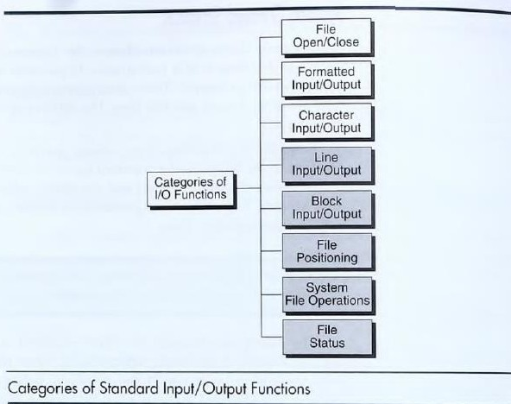
File opening modes

Mode | Meaning
r | Open text file in read mode  If the file exists, the marker is positioned at the beginning. If file doesn’t exist, error returned.
w | Open text file in write mode If the file exists, it is erased.  If file doesn’t exist, it is created.
a | Open text file in append mode  If the file exists, the marker is positioned to the end. If file doesn’t exist, it is created.

Formatting Input/Output functions: fscanf() and fprintf()
- To work with all types of data (int, float, char, etc), C provides a set of formatted input/output functions. They are fscanf() and fprintf().
- The fscanf function receives a text stream from the file and converts it to data values to be stored in variables.
- The fprintf function receives data values from the program and converts them into text stream to be stored in the file.
- These functions are used for formatted input and output. These are identical to scanf() and printf() except that the first argument is a file pointer that specifies the file to be read or written, the second argument is the *format string.
- The syntax for these functions is:

int fscanf(FILE *fp, char *format,. . .);

int fprintf(FILE *fp, char *format,. . .);
fprintf():
#include<stdio.h> #include<stdlib.h> void main() {  FILE *fp; int roll;  char name[25]; float marks; char ch;  fp = fopen("file.txt","w"); //Statement 1 if(fp == NULL) {  printf("\nCan't open file or file doesn't exist."); exit(0);  }  do {  printf("\nEnter Roll : "); scanf("%d",&roll); printf("\nEnter Name : "); scanf("%s",name); printf("\nEnter Marks : ");  scanf("%f",&marks); | Output:  Enter Roll : 533 Enter Name : James Enter Marks : 67  Do you want to add another data (y/n) : y  Data written successfully... Enter Roll : 577  Enter Name : John Enter Marks : 89  Do you want to add another data (y/n) : n  Data written successfully...

}
fprintf(fp,"%d%s%f",roll,name,marks); printf("\nDo you want to add another data (y/n) : "); ch = getchar();
}while(ch=='y' || ch=='Y');
printf("\nData written successfully..."); fclose(fp);

fscanf()

#include<stdio.h> #include<stdlib.h> void main() { FILE *fp;  char ch;  fp = fopen("file.txt","r"); //Statement 1 if(fp == NULL) {  printf("\nCan't open file or file doesn't exist."); exit(0);  }  printf("\nData in file...\n"); while((fscanf(fp,"%d%s%f",&roll,name,&marks))!=EOF)  //Statement 2  printf("\n%d\t%s\t%f",roll,name,marks); fclose(fp);  } | Output:  Data in file…  533 James 67  577 John 89

/* Write a program in C to copy a file in another name.  */ #include<stdio.h> #include<stdlib.h> int main() {  FILE *fp1,*fp2; int a,b;  fp1=fopen("one.txt", "w"); if(fp1!= NULL) {  printf("Enter a and b values from key board: \n"); scanf("%d%d",&a,&b); /* read from keyboard */ fprintf(fp1, "%d %d", a, b); /* write to file */  }  else printf("Cannot open file.\n");  fclose(fp1);  if((fp1=fopen("one.txt", "r")) == NULL) { printf("Cannot open file.\n");  exit(1);  }  else{  if((fp2=fopen("two.txt", "w")) != NULL) { fscanf(fp1, "%d%d", &a, &b); /* read from file */ fprintf(fp2, "A \t B \n"); | Output:  Enter a and b values from key board:  20  10  one.txt :  20 10  two.txt:  A B  20 10  Copied successfully
fprintf(fp2, "%d \t %d", a,b);
}
}
printf("copied successfully"); fclose(fp1);
fclose(fp2); return 0;
}
Append
#include<stdio.h> #include<stdlib.h> void main() {  FILE *fp; int roll;  char name[25]; float marks; char ch;  fp=fopen("file1.txt","a");  //Statement 1  if(fp == NULL) {  printf("\nCan't open file or file doesn't exist."); exit(0);  }  do {  printf("\nEnter Roll : "); scanf("%d",&roll); printf("\nEnter Name : "); scanf("%s",name);  printf("\nEnter Marks : "); scanf("%f",&marks); fprintf(fp,"%d%s%f",roll,name,marks); printf("\nDo you want to add another data  (y/n) : ");  ch = getchar();  }while(ch=='y' || ch=='Y'); printf("\nData appended successfully..."); fclose(fp);  } | Output:  Enter Roll: 590 Enter Name: Peter Enter Marks: 88  Do you want to add another data(y/n):n  Data appended successfully

Character Input/ Output Functions
- Character input functions read one character at a time from a text stream. Character output functions write one character at the time to a text stream.

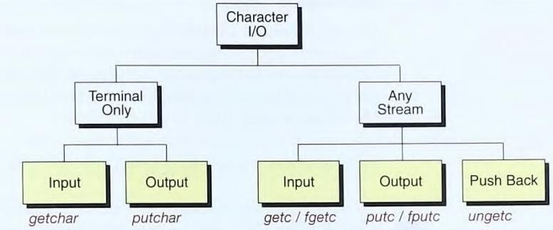

getc()

The getc( ) function reads characters from a file opened in read mode by fopen( ).

int getc(FILE *fp);

- where fp is a file pointer of type FILE returned by fopen( ).
- getc( ) returns an integer, but the character is contained in the low-order byte. The getc( ) function returns an EOF when the end of the file has been reached.
putc():
- putc( ) is used to write a character to a file.
- Their syntax is as follows:

int putc(int ch, FILE *fp);
- where fp is the file pointer returned by fopen( ), and ch is the character to be output.
- If a putc( ) operation is successful, it returns the character written. Otherwise, it returns EOF.
fgetc() and fputc():
- C also defines equivalent functions to read / write characters from / to a file. These are:
int fgetc(FILE *fp);
int fputc(int c, FILE *fp);
feof( ):
- feof( ) is used to check for the end of the file.

int feof(FILE *fp);
- feof( ) returns true if the end of the file has been reached; otherwise, it returns zero
Program : Write a program to copy one file to another.
/*Program to copy one file to another */

#include<stdio.h> main(){  FILE *fp1,*fp2,*fp3; int i=0;  char ch[]="copying file content to another  file",c; | if((fp2=fopen("d1.txt","r"))!=NULL &&  (fp3=fopen("d2.txt","w"))!=NULL) { while (!feof(fp2)) {  c=fgetc(fp2); printf(“\ncontent of file:2\n”);  fputc(c, fp3);

if((fp1=fopen("d1.txt","w"))!=NULL)  {  i=0;  while(ch[i]!='\0') { printf(“\ncontent of file:1\n”); c=ch[i];  printf("%c ",c); i++;  fputc(c, fp1);  }  }  else  printf("file not opened"); fclose(fp1); | printf("%c", c);  }  }  else  printf("file not opened"); fclose(fp2);  fclose(fp3);  }  Output:  content of file:1  copying file content to another file content of file:2  copying file content to another file

Binary files

Standard library functions for files
- fread
- fwrite

fread( ) and fwrite( ):
- To read and write data types that are longer than 1 byte, the C file system provides two functions:
fread( ) and fwrite( ).
- These functions allow the reading and writing of blocks of any type of data.

size_t fread (void *buffer, size_t num_bytes, size_t count, FILE *fp);
size_t fwrite (const void *buffer, size_t num_bytes, size_t count, FILE *fp);
- For fread( ), buffer is a pointer to a region of memory that will receive the data from the file.
- For fwrite( ), buffer is a pointer to the information that will be written to the file.
- The value of count determines how many items are read or written, with each item being
num bytes in length.
- fp is a file pointer to a previously opened stream.
- The fread( ) function returns the number of items read. This value may be less than count
if the end of the file is reached or an error occurs.
- The fwrite( ) function returns the number of items written. This value will equal count
unless an error occurs.

EXAMPLE:  void main() {  struct employee { int eid;  char name[20]; char addres[20];  }; | Output:  In terminal:  enter employee details 1001  Manoj Guntur Eid=1001

FILE *Fp;  struct employee emp;  if((fp=fopen("one.txt", "w")) == NULL) { printf(''Cannot open file.\n");  exit(1);  }  printf(“ enter employee details \n”); Scanf(“%d%s%s”,&emp. eid, emp.name, emp.  address);  fwrite(&emp, sizeof(emp),1,fp); fclose(fp);  if((fp=fopen("one.txt", "r")) == NULL) { printf(''Cannot open file.\n");  exit(1);  }  printf(“ display the employee details from one.txt file  \n”);  fread(&emp, sizeof(emp),1,fp); printf(“Eid=%d\n Ename=%s\nAddress=%s\n”, emp.eid, emp.ename, emp.address);  fclose(fp);  } | Ename Manoj Address= Guntur  In file “one.txt”  1001 Manoj Guntur

Positioning functions/ Random-Access I/O

fseek()
- fseek() function is used to move the file position to a desired location within the file.
int fseek(FILE *fp, long int numbytes, int origin);
- Here, fp is a file pointer returned by a call to fopen( ),
- numbytes is the number of bytes that pointer moves from origin, which will become the new current position, and
- origin is one of the following macros:
Origin | Macro Name | value
Beginning of file | SEEK_SET | 0
Current position | SEEK_CUR | 1
End of file | SEEK_END | 2

- To seek numbytes from the start of the file, origin should be SEEK_SET.
- To seek from the current position, use SEEK_CUR, and
- To seek from the end of the file, use SEEK_END.
- The fseek( ) function returns zero when successful and a nonzero value if an error occurs.
- The numbytes may be +ve, meaning moving forward or _ve , meaning moving backward.

Examples:
Statement Meaning
- fseek(fp,0l,0) Go to the beginning.
- fseek(fp,0l,1) Stay at current position.
- fseek(fp,0l,2) Go to the end of the file, past the last character of the file.
- fseek(fp,m,0) move to (m+1)^{th} byte in the file.
- fseek(fp,m,1) Go Forward by m bytes.
- fseek(fp,-m,1) Go Backward by m bytes from the current position.
- fseek(fp,-m,2) Go Backward by m bytes from the end.

ftell():
- ftell() returns the location of the current position of the file associated with fp. If a failure occurs, it returns –1.
long int ftell(FILE *fp);
- ftell takes a file pointer as argument and return a number of types long that corresponds to the current position.

rewind( ):
- The rewind( ) function moves the file position indicator to the start of the specified file. void rewind(FILE *fp);
- It also clears the end-of-file and error flags associated with file.
- This function helps us reading the file more than once, without having to close and open the file.

Example : fseek(), ftell(), rewind()

#include <stdio.h> void main(){  FILE *fp; clrscr();  fp = fopen("myfile.txt","w+");  fputs("This is fseek , ftell, rewind demo using fgets", fp); fclose(fp);  fp = fopen("myfile.txt","r+");  printf("the cursor position %d\n",ftell(fp));  fseek( fp, 7, SEEK_SET );  printf("\nthe cursor position %d\n",ftell(fp));  rewind(fp);  printf("\nthe cursor position %d\n",ftell(fp)); fclose(fp); getch();  } | Output:  The cursor position 0 The cursor position 7 The cursor position 0

Assignment questions
- What is a file? Explain diverse types of files in C. write a c program to copy content of one file to another file.
- Write a C program to read and display the contents of a file.
- What is call-by-value and call-by-reference? Explain with an example program.
- What is recursion function? Explain the concept with an example program.
- Explain about formatting input/output functions(fprintf/fscanf)?
- Explain about Character Input/Output file Functions
- Explain about fread and fwrite.
- Explain about file positioning functions.
- Explain about user defined functions
- Explain about function declaration, function call and function definition.

Old question paper questions
  - Write a recursive function for finding the factorial value of a given number.
  - What is the difference between recursive and non-recursive functions?
  - Explain different parameter passing techniques in functions with examples
  - Write C program find the Greatest Common Divisor (GCD) of two numbers using a recursive function.

